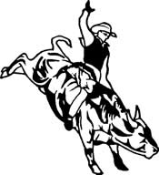
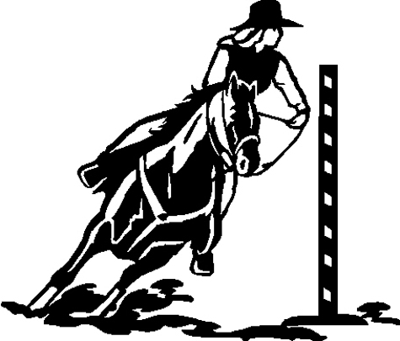
La Junta Kid’s Rodeo & Race Meet
P.O. Box 155 La Junta, CO 81050
www.ljkidsrodeo.com

We are excited to announce that this is our 86th Annual La Junta Kid’s Rodeo & Race Meet! To our past sponsors we would like to send out a big thank you! Without your generous support, we would not be able to put our rodeo on.

For our new prospective sponsors, we would like to take a moment to explain how our rodeo is organized. Our girls and boys compete separately in 3 age divisions which are Tiny Tots, Juniors, and Seniors. In addition to our contestants who come to us from the Arkansas Valley, we also draw kids from all over Colorado and the surrounding states. All the donations that we receive go directly to the kids for their prizes.

With the donations that we receive, we are able to give some really great prizes! We hope to be able to do this year as well with your support. The awards we give are as follows:
- All – Around Cowboy and Cowgirl in each age division receive saddles
- 1st Runner-up in each age division
- Arena Champs and Jockey Champs
- The top 3 contestants in each event
- Hard Luck Cowboy and Cowgirl
- Sportsmanship award to 1 boy and 1 girl in each division
- Our royalty also receive prizes

As board members of the La Junta Kid’s Rodeo we take pride in giving our
kids quality awards. We would like to remind you that we run our rodeo solely on the help of volunteers and the generosity of our wonderful support system we have developed in this community.

Please see contact and sponsorship information on the reverse side.

We would like to ask for your help in the form of a tax-deductible donation (we have a 501(c)(3) classification).

In return for your tax-deductible donation, full and half saddle sponsors will have a fence banner made and displayed on the arena fence during all three performances of the rodeo. Everyone who donates will be listed in our program along with being announced as a sponsor during the rodeo performances. Your name will also be placed on the list of sponsors on our website.

If we can answer any questions that you might have, please feel free to contact us by email at ljkidsrodeo@yahoo.com; by mail at La Junta Kid’s Rodeo, P.O. Box 155,
La Junta, CO 81050; or you may phone us at (719) 242-8186 or (719)468-8041. Please feel free to log onto our web site (www.ljkidsrodeo.com) for more information on our rodeo and some snap shots of the kids from previous years.

Thank you very much! La Junta Kid’s Rodeo
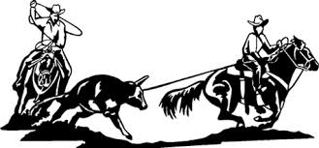

Please remit with sponsorship

◻ Full Saddle Sponsor with fence banner $800.00

◻ Half Saddle Sponsor with fence banner $450.00

◻ Quarter Saddle Sponsor $200.00

◻ 1st Runner up to All Around $125.00

◻ Arena Champ $65.00

◻ Jockey Champ $65.00

◻ First Place Event Award $50.00

◻ Second Place Event Award $30.00

◻ Third Place Event Award $20.00

◻ Or feel free to donate whatever product or amount you want________

